**INTRODUCTION**

* 1. **Overview**

Today, because of social distancing and other issues it can be risky for some people to shop for essential items in person. This project helps with this issue by giving people an online option to shop for essentials.

* 1. **Purpose**

With the help of Watson assistant, a chatbot is built which are having the following capabilities:

1. Give the list of items in the Store.
2. It shows the prices of vegetables.
3. It displays the offers or discounts to the customers.
4. The bot is able to take details like name, contact number, email address, and the items to place the order.

**LITERATURE SURVEY**

* 1. **Existing Problem**

The Covid 19 pandemic has made Social Distancing a way of life. It is essential to minimise physical contact with strangers to control the spread of the disease. However, there are some situations where people are forced to go out – one of them being to shop for essentials. It is imperative that this problem be resolved to control the spread of the disease.

* 1. **Proposed Solution**

I am making a Glossary Store Chatbot which can show the price list, lists of products, offers or discount and take details of the customer. Customer can pay the bill amount using Cash on delivery (COD), UPI or by using card. Customer can buy products online with the help of this chatbot. I am using Watson Assistant platform to make this chatbot then I have interfaced this chatbot with Node-red application for customer interaction.

**THEORITICAL ANALYSIS**

* 1. **Block Diagram**

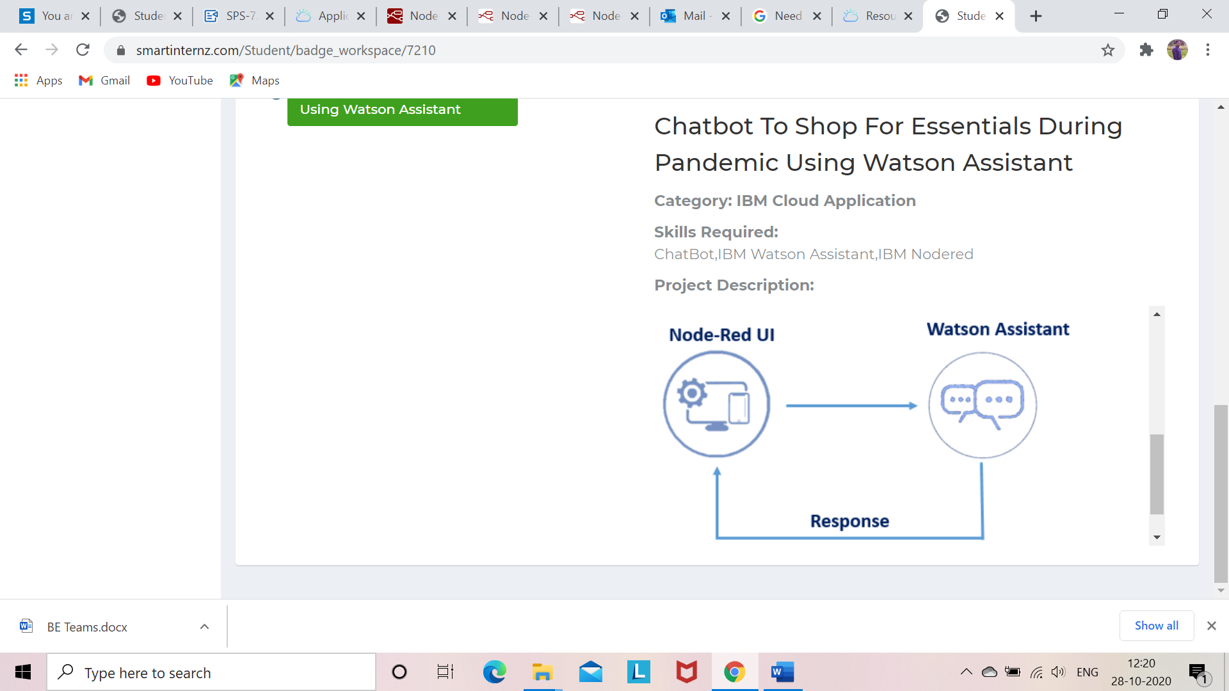

* 1. **Hardware/Software Designing**

1. **IBM Watson Assistant**: Watson Assistant is IBM's AI product that is used to build, train, and deploy conversational interactions into any application, device or channel.
2. **Node-RED:** It is a flow-based development tool for visual programming developed by IBM for wiring together hardware devices, APIs and online services as part of the Internet of Things. Node-RED provides a web browser-based flow editor, which can be used to create JavaScript functions.

**PROCESS FLOW**

1. Create account on IBM cloud and smartinternz using institutional ID.
2. Using Watson Assistant services from IBM cloud, the bot implementation has been done which includes following:
3. Intents which are the user input. It includes #enquiry, #greetings and #order.
4. Entities which are keyword extracted from intent. In my project I have implemented following entities: @email, @enquiry, @greetings, @items, @mobile and @order
5. Dialog: Which is conversation by bot to user input. It has been implemented using various nodes as well as various child node.
6. This chat bot is integrated with Node-Red to create user interface.

**Results**

1. **Watson Assistant Results:**

**Test link:**

<https://web-chat.global.assistant.watson.cloud.ibm.com/preview.html?region=eu-gb&integrationID=8f56bf69-3806-499a-9e78-caa624582ed8&serviceInstanceID=712402c7-7f84-4253-b00d-166fc100099b>

**1: Name and mail ID Input:**

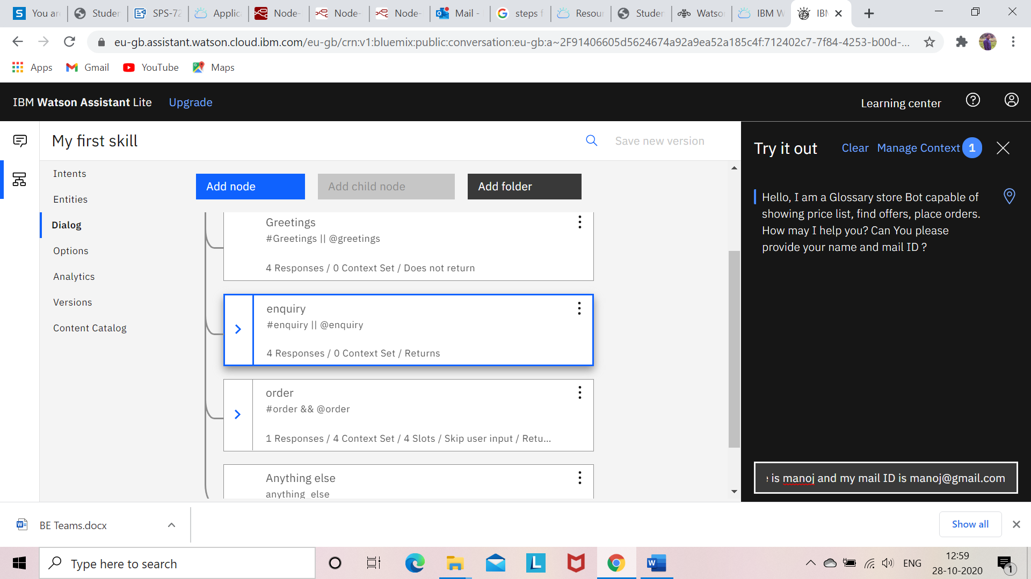

**2: Mobile Number input:**

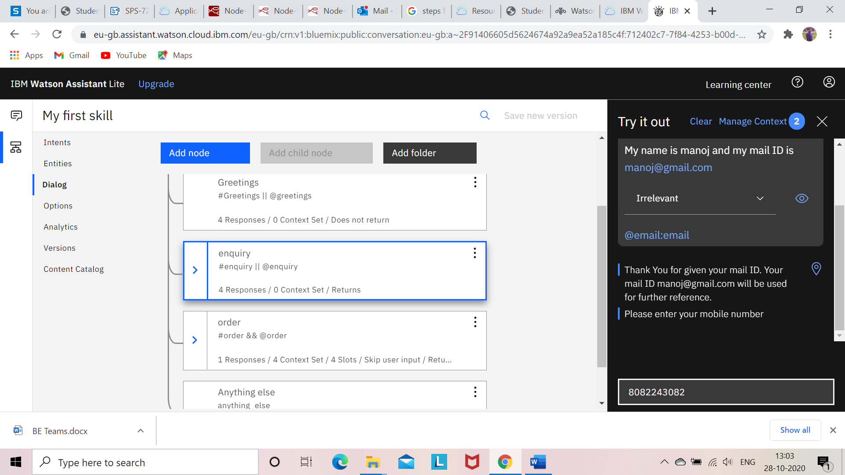

**3: List of Items:**

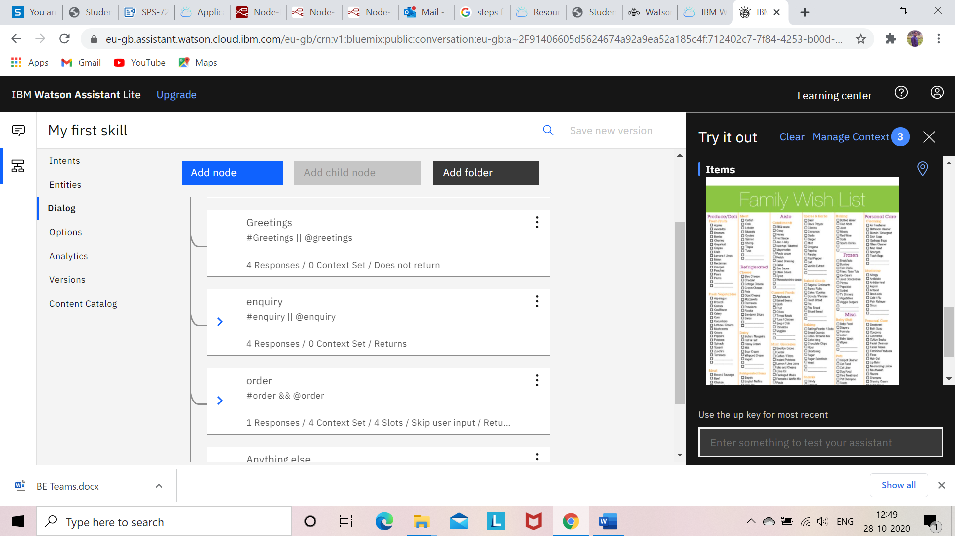

**4: Price list of the Vegetables:**

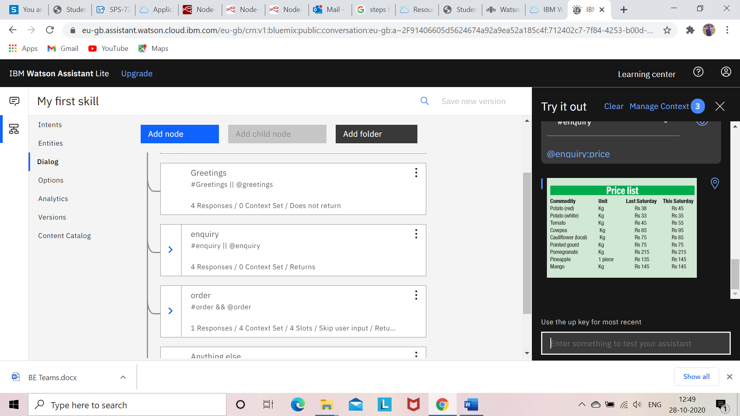

**5: Offers available:**

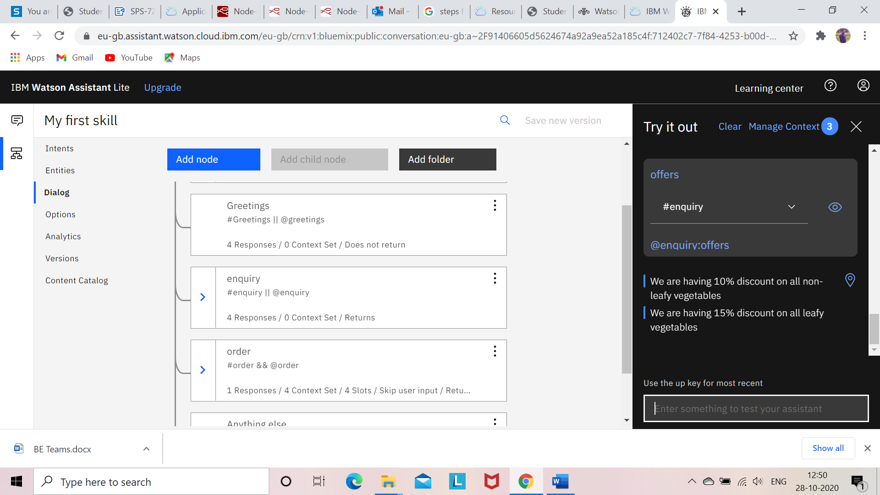

**6: Special Vegetables:**

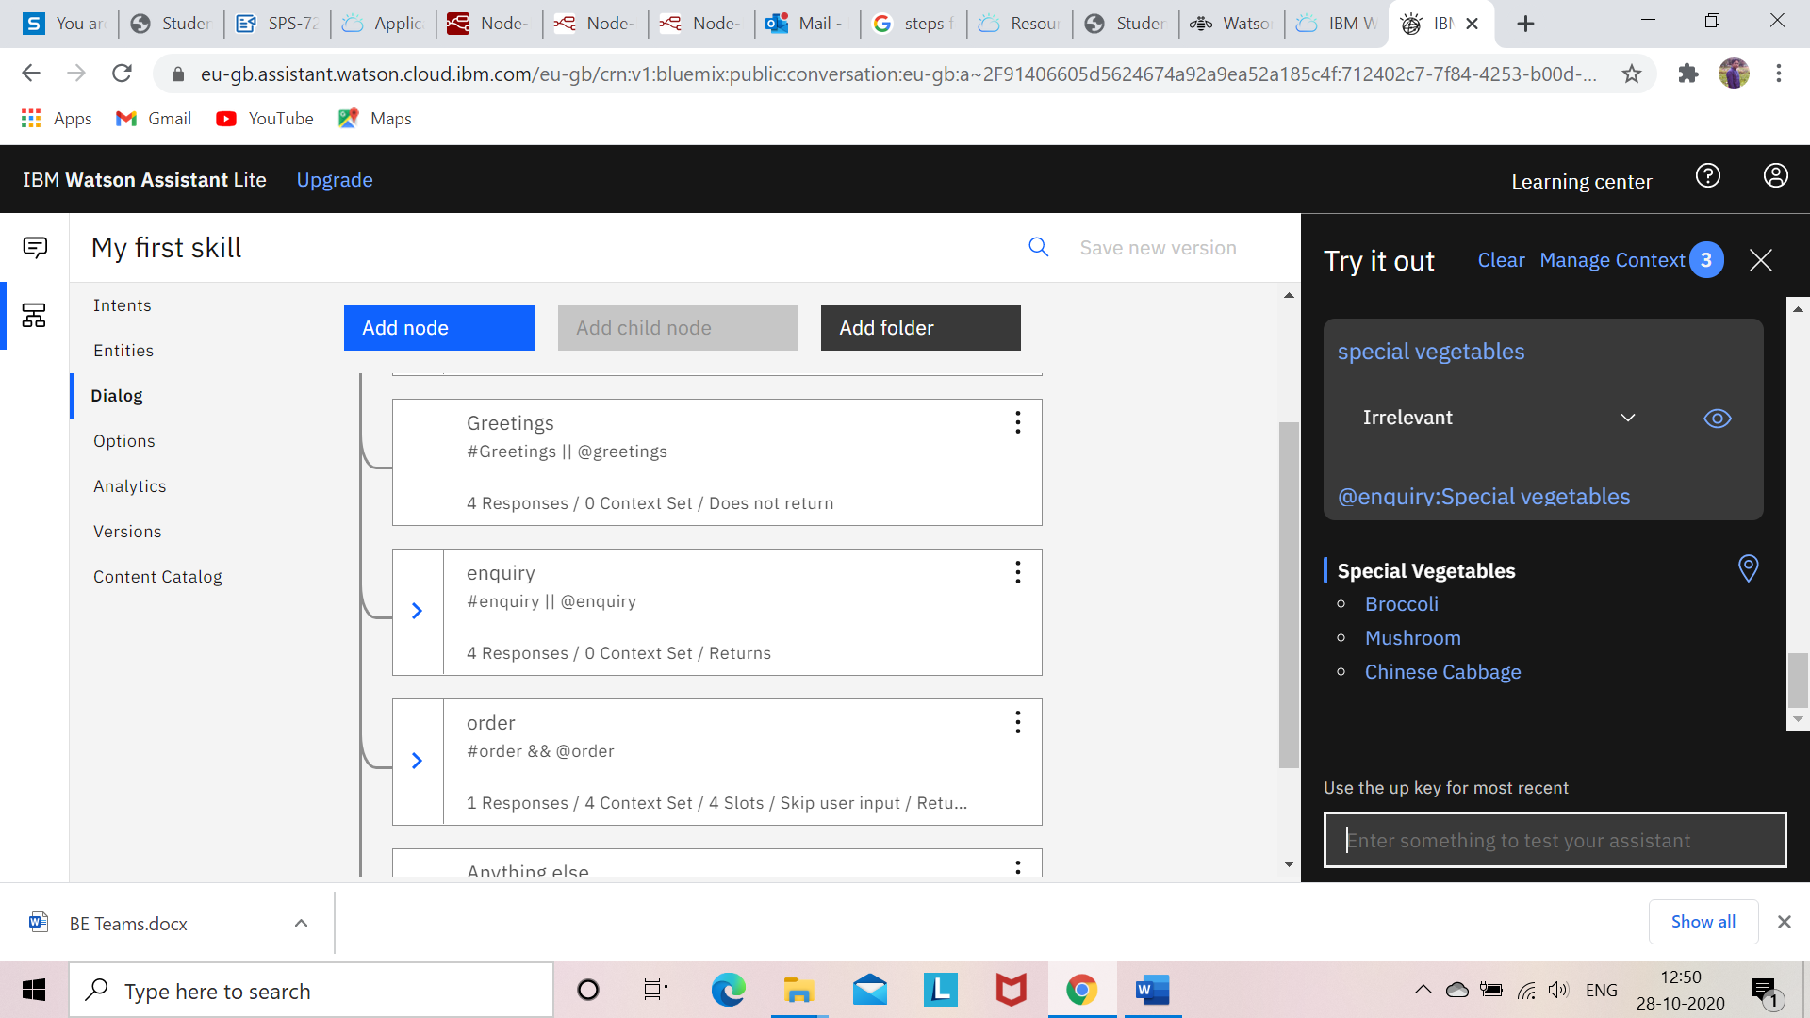

**7: Broccoli Input response:**

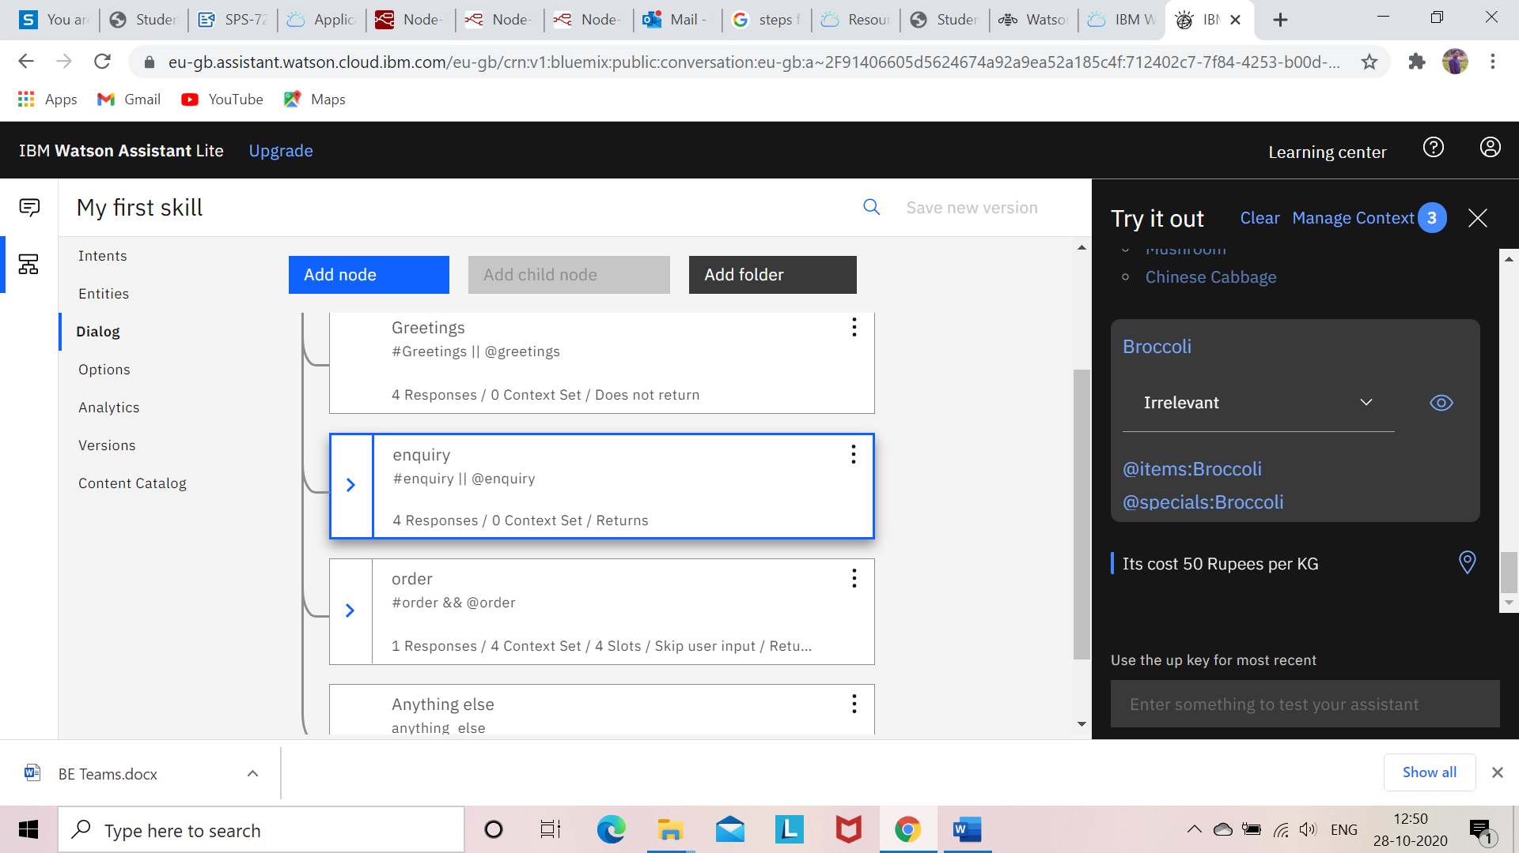

**8: Mushroom Input response:**

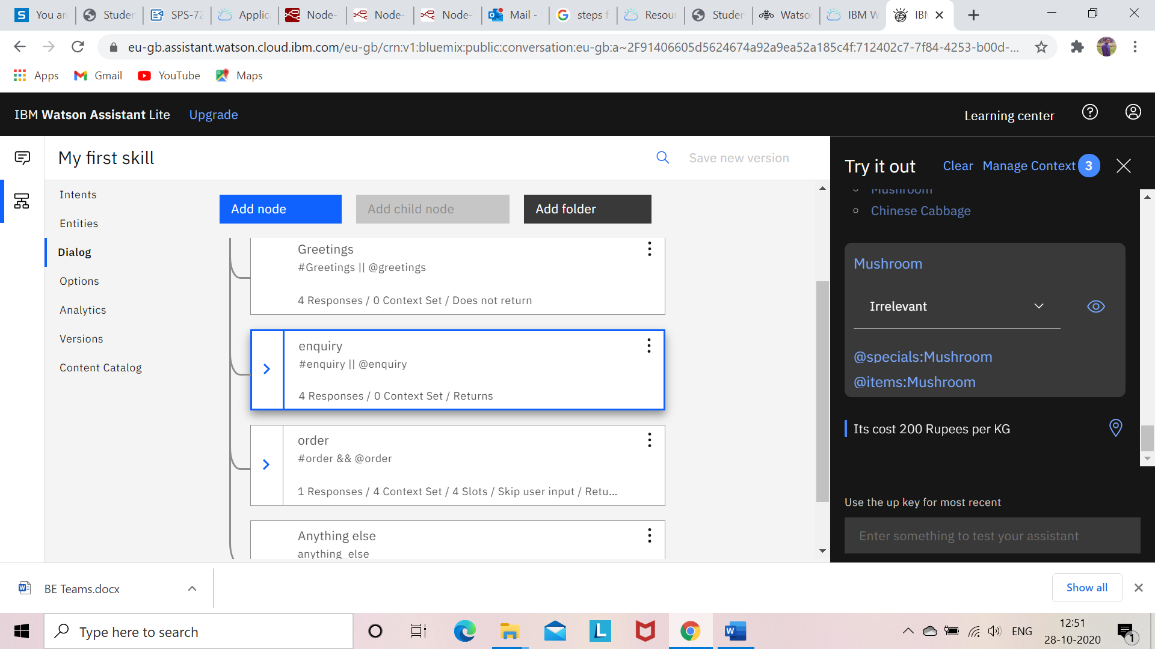

**9: Chinese Cabbage Input response:**

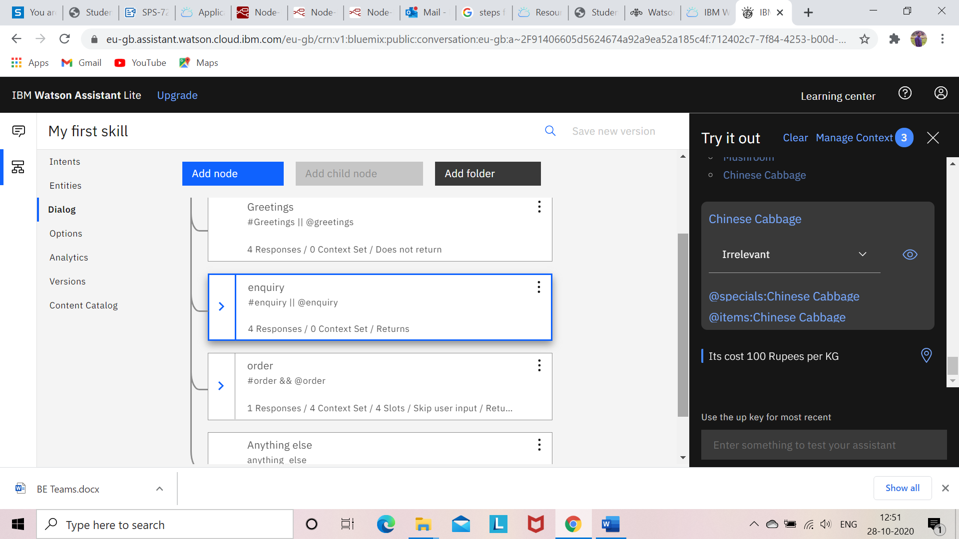

**10: Order responses:**

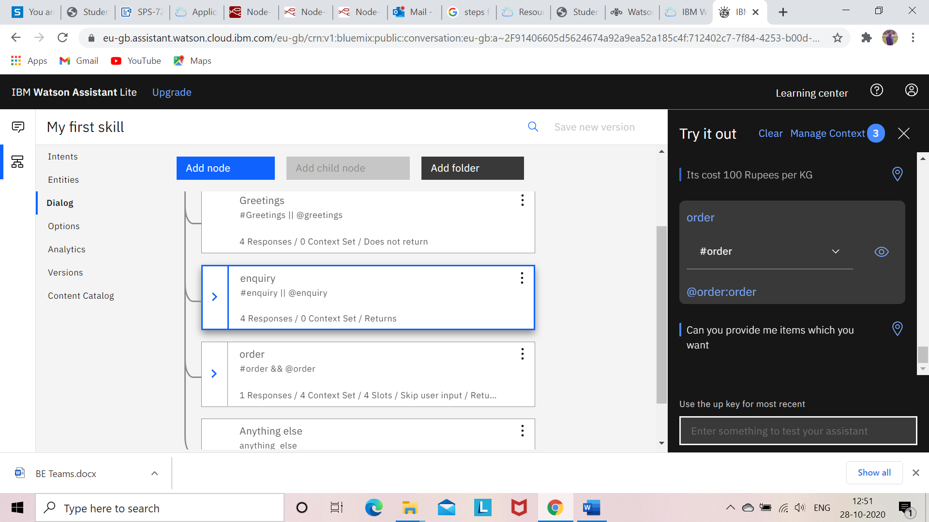

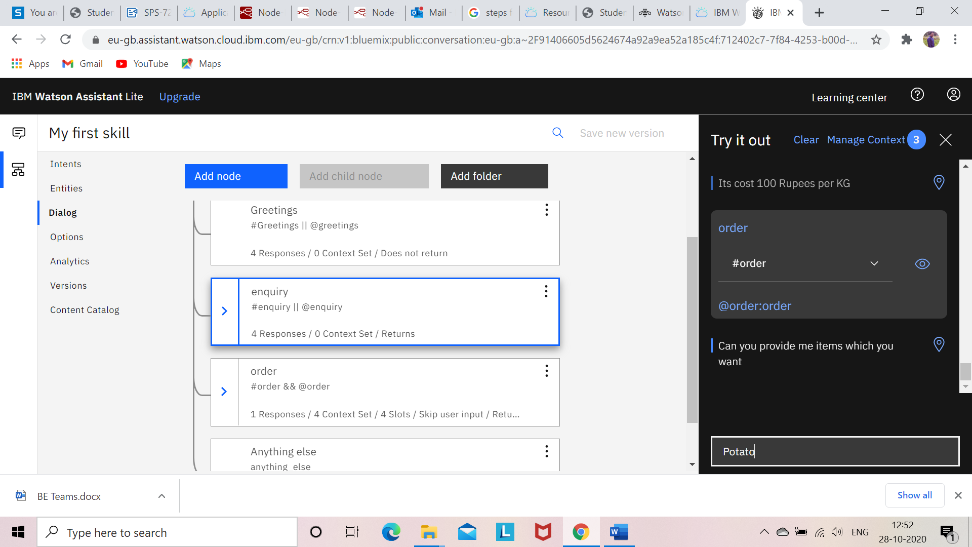

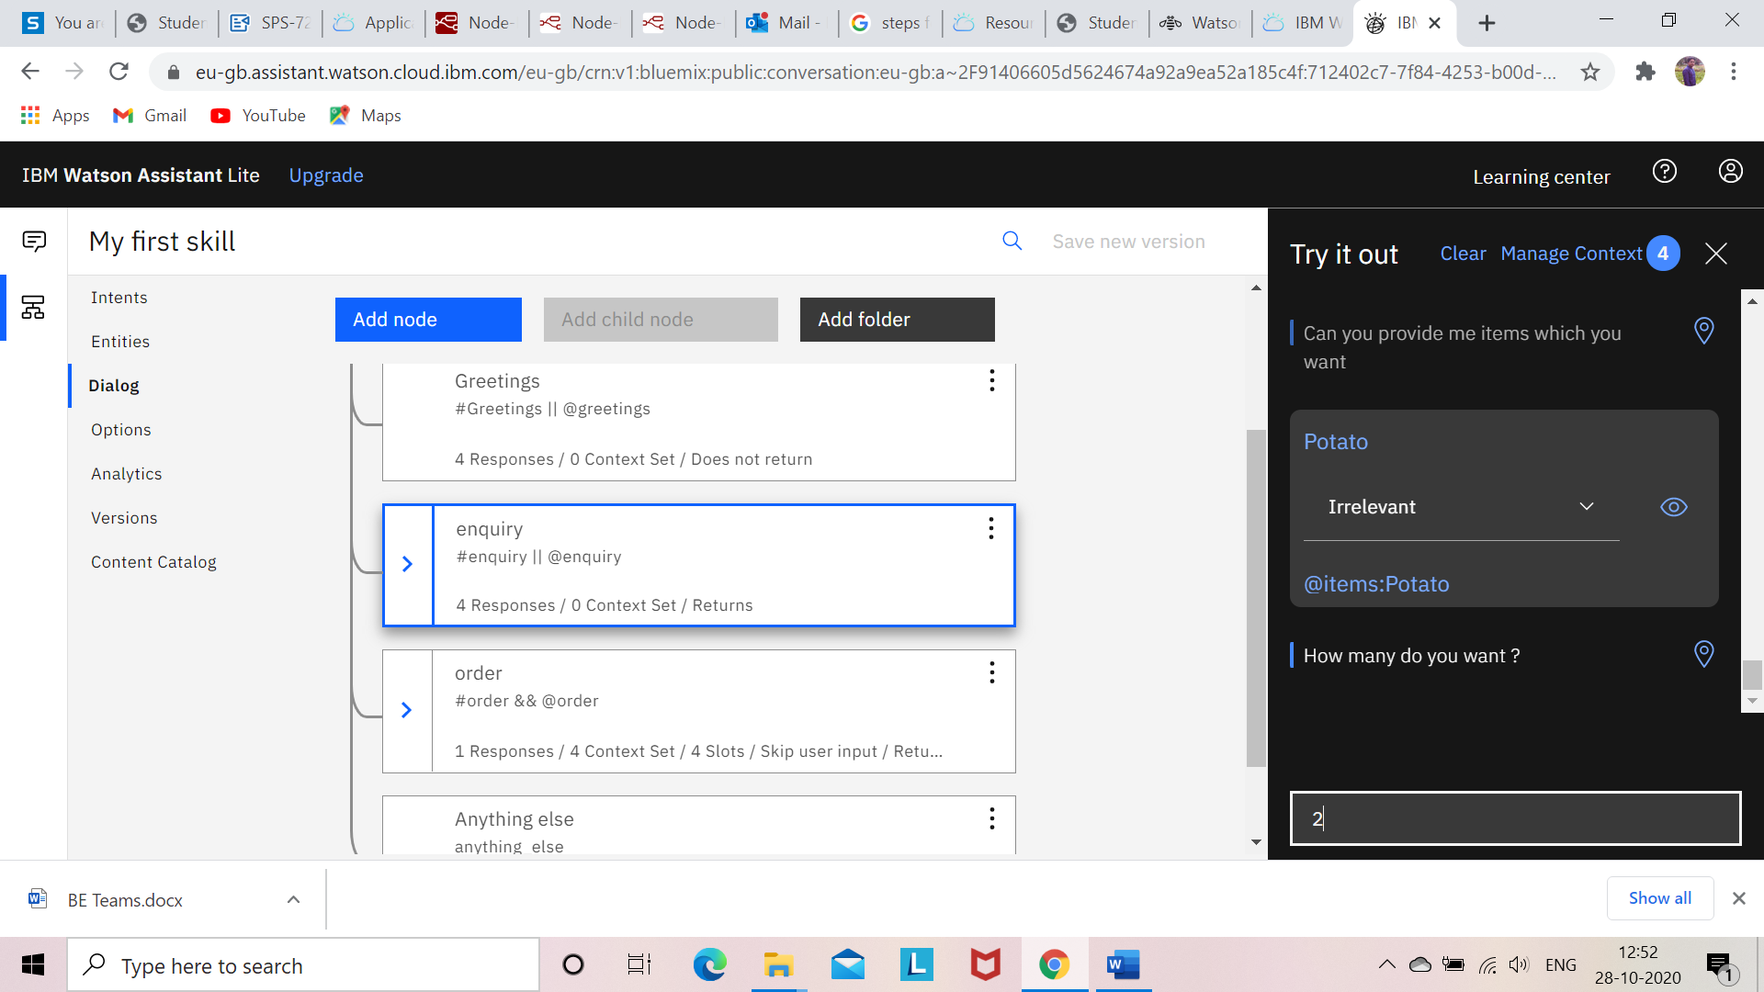

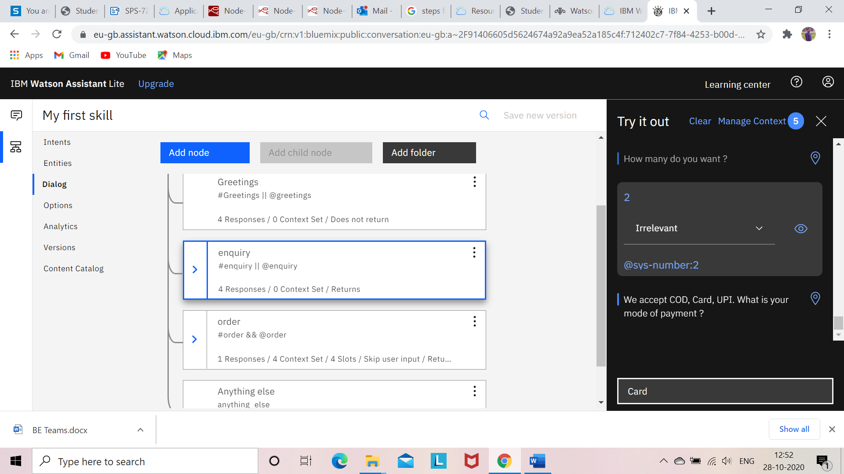

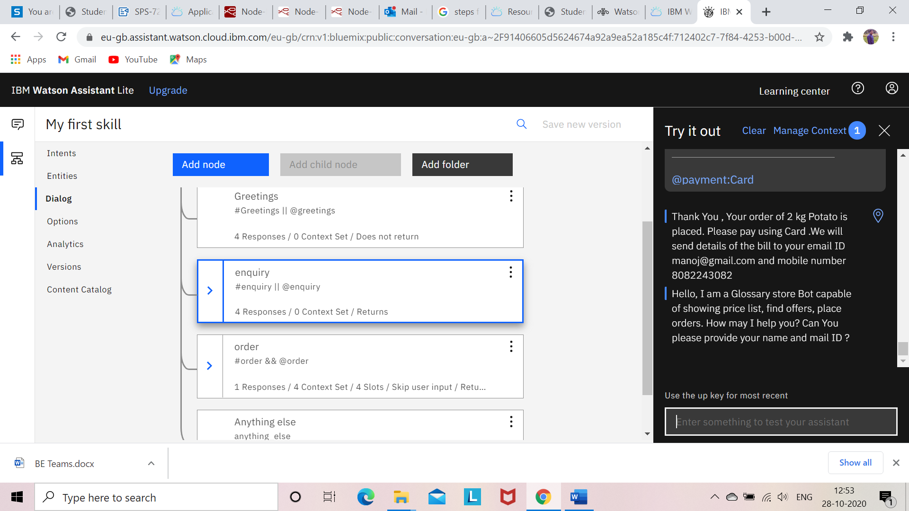

1. **Node-Red Results:**

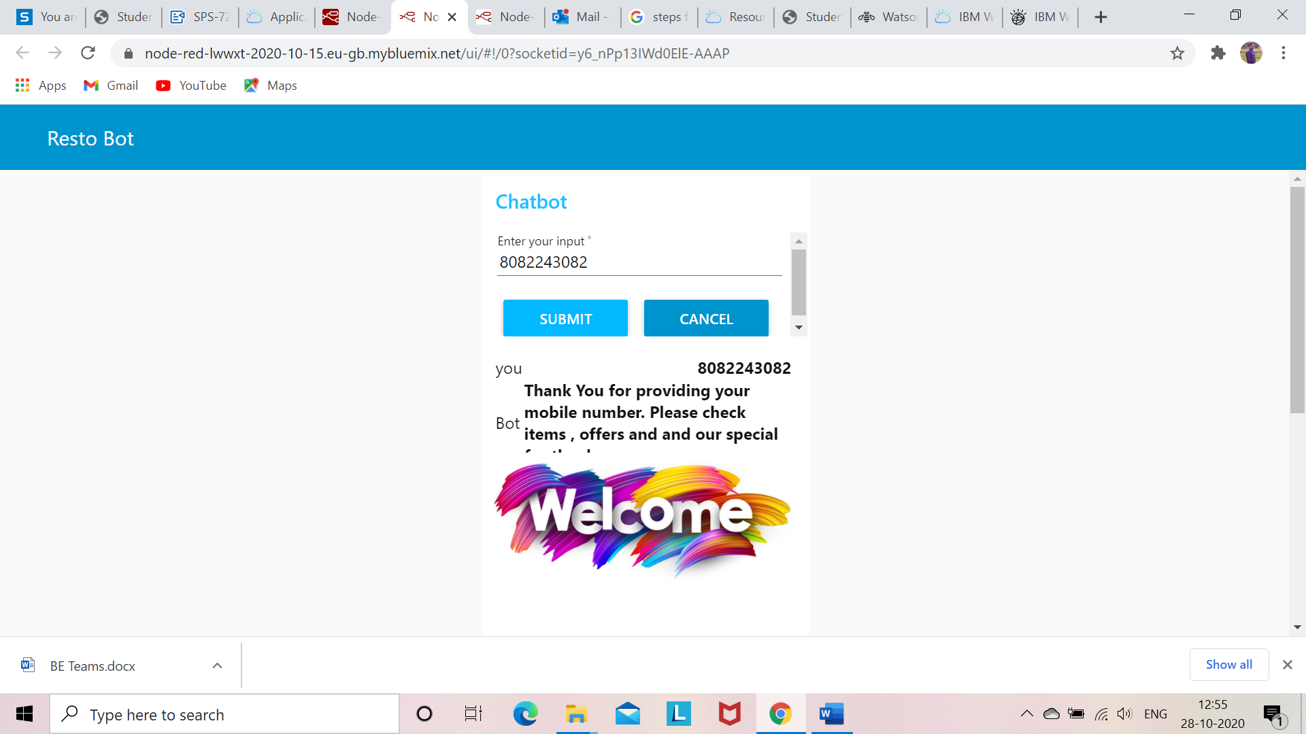

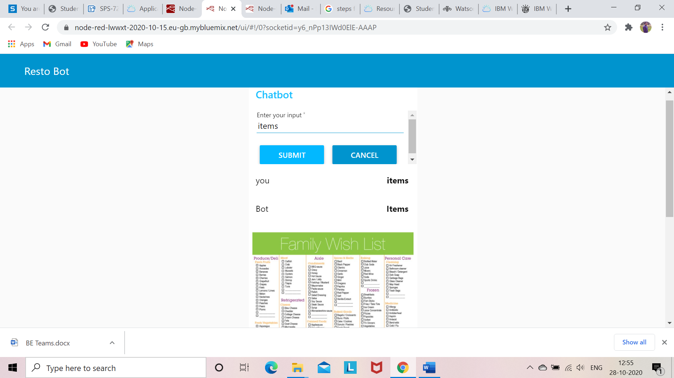

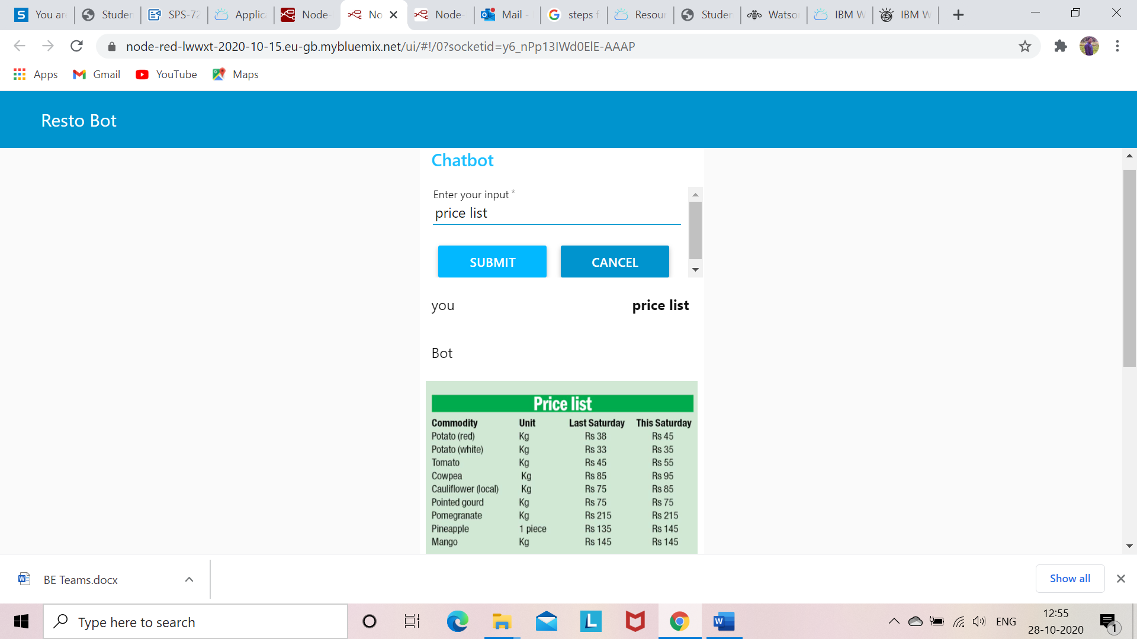

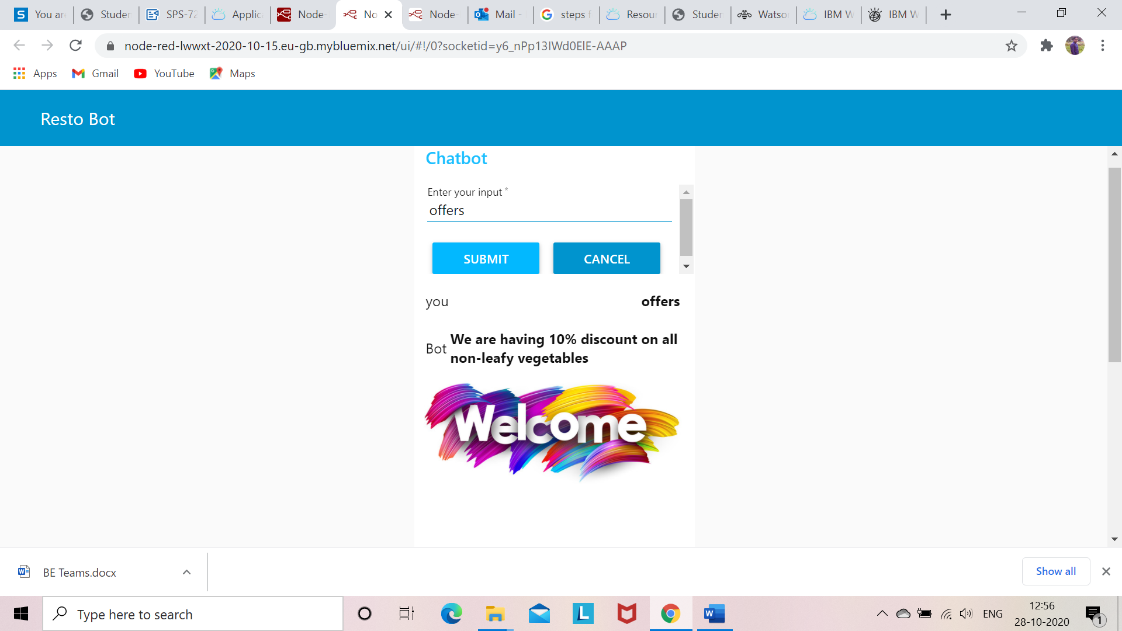

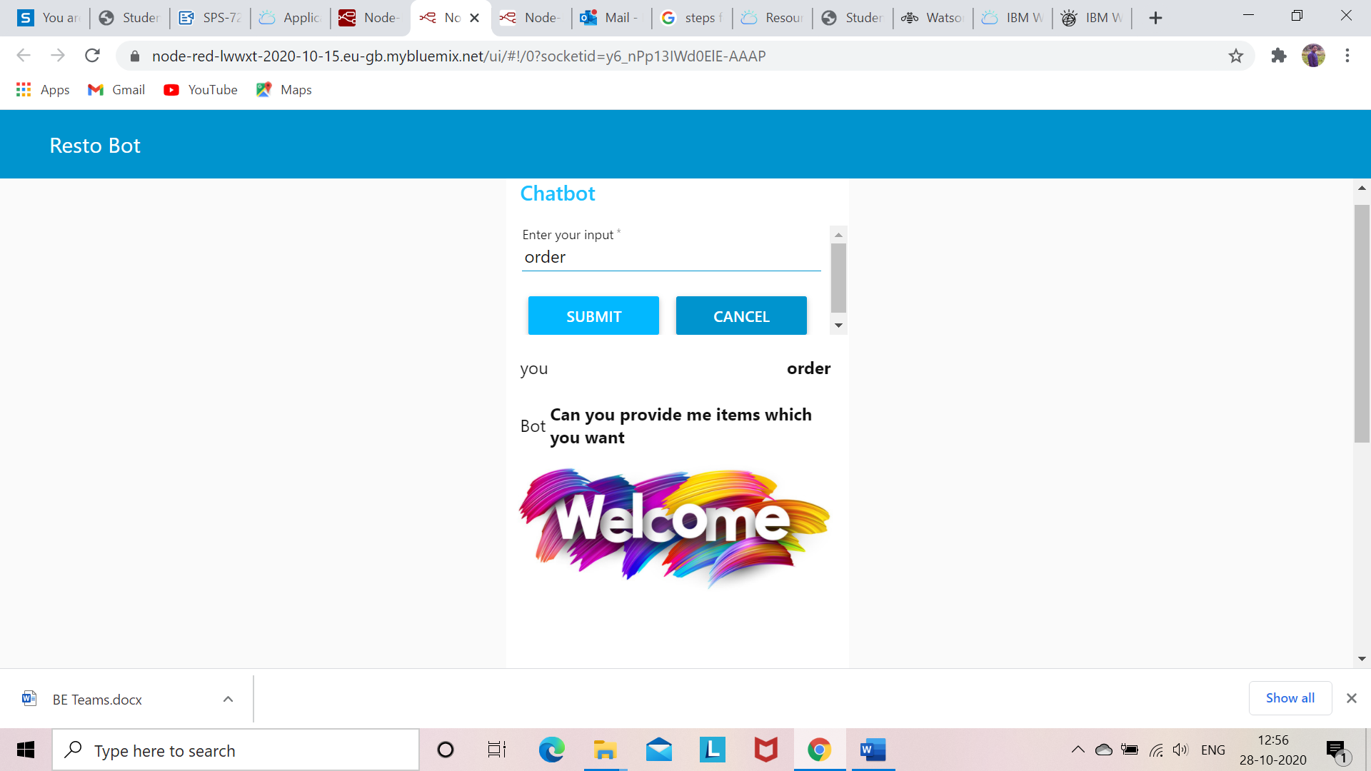

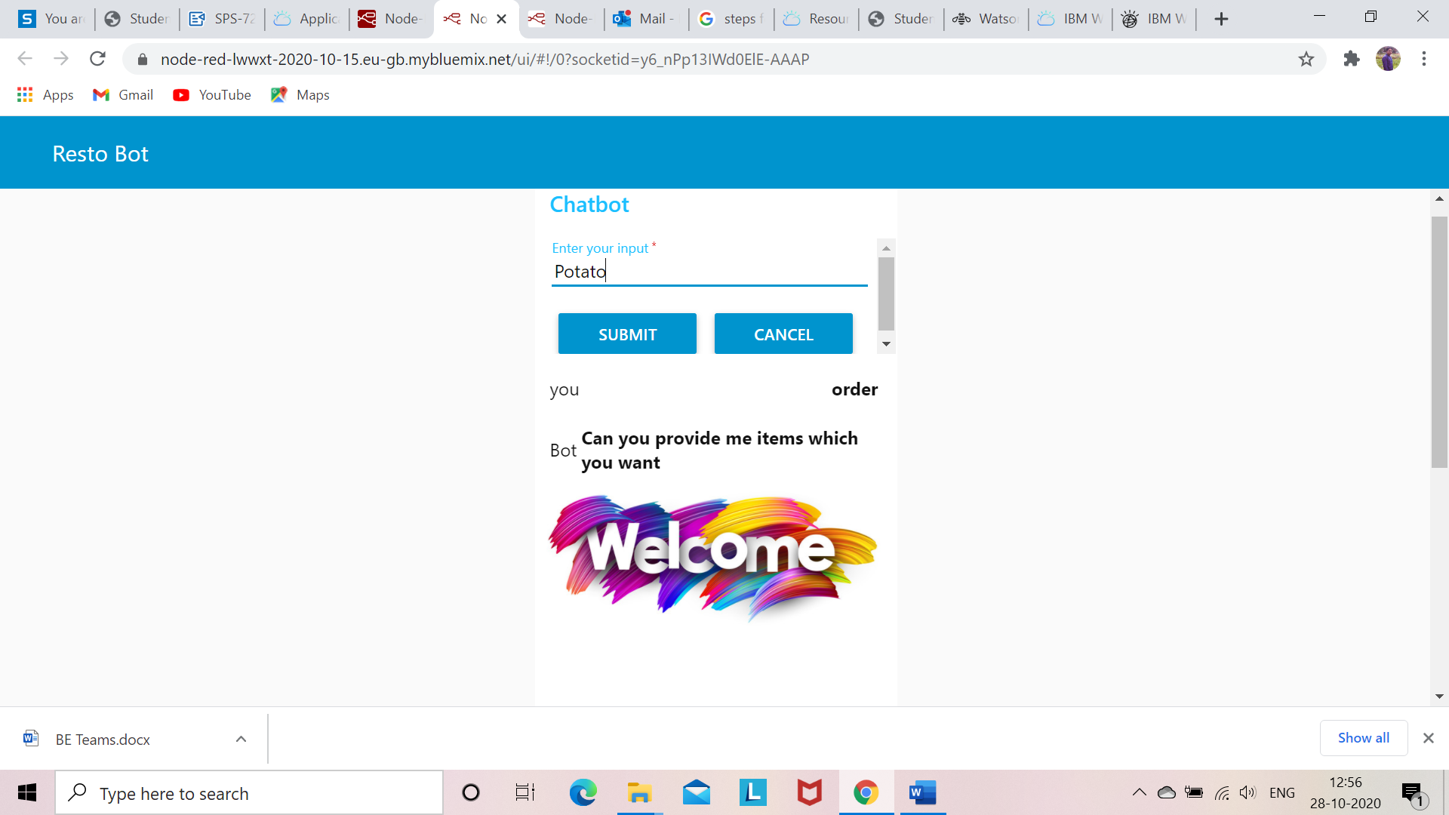

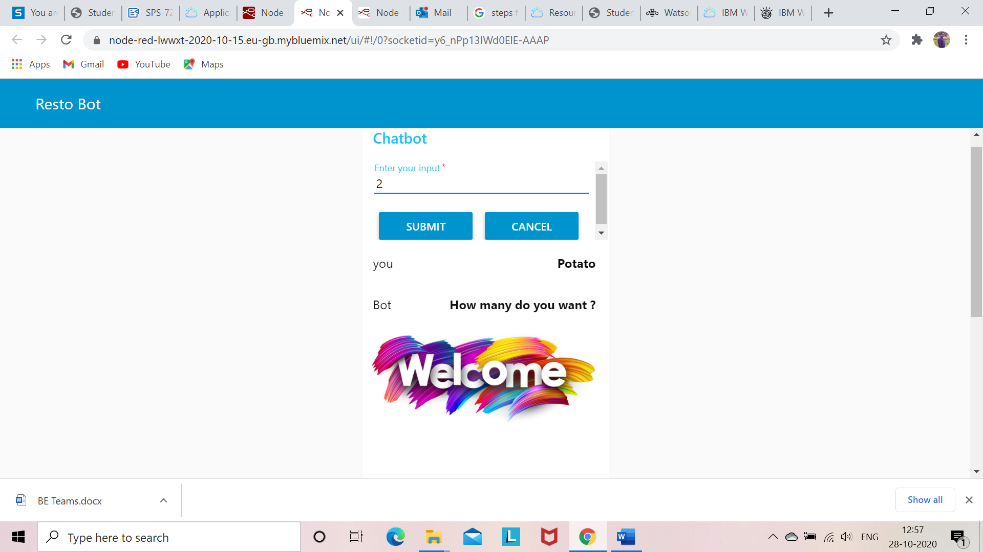

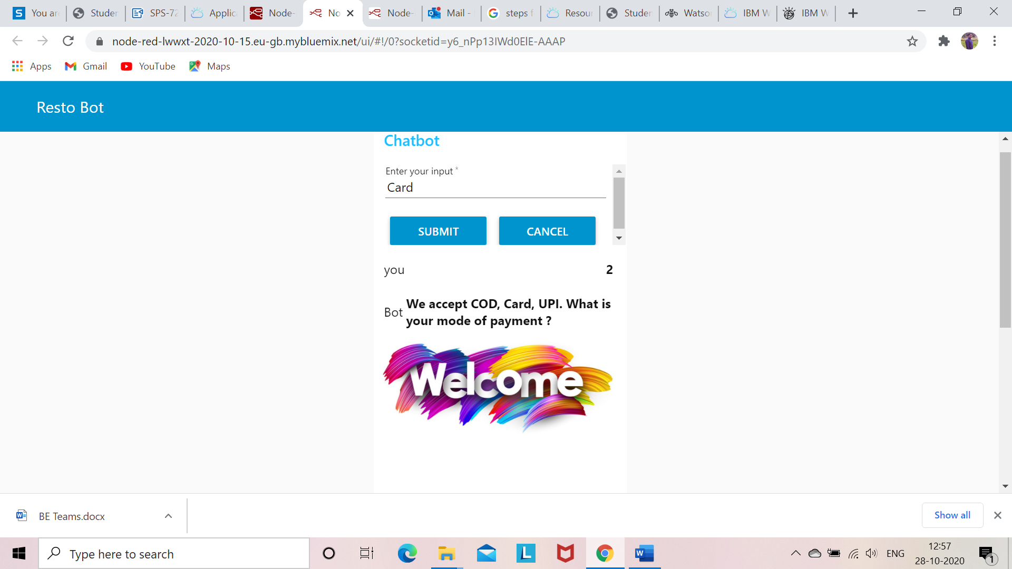

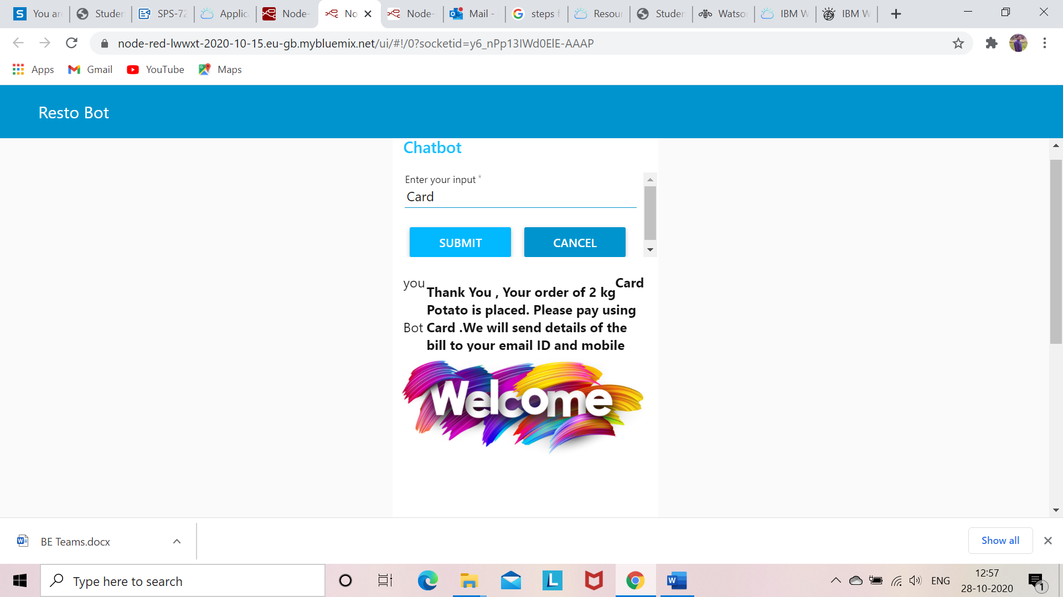

**ADVANTAGES**

* This system ensures minimum physical contact and hence ensures control in spread of the pandemic.
* It offers the convenience of shopping from Home

**DISADVANTAGES**

* It is necessary that the person should have same understanding of how to work online and with Apps.
* Security is still an issue and people need to be very careful with regards to cyber frauds

**APPLICATIONS**

Many online portals now use a chat bot to converse with customers/clients. This saves on investing human resources for this activity. Only when the bot is unable to satisfactorily answer the queries the customer may be directed to the Human Interface.

**CONCLUSION**

The Chatbot for shopping of essentials has been successfully built using Watson Assistant and Node Red.

**FUTURE SCOPE**

Chatbots are the way online interactions with various shopping portals will happen in the future. Many Banks and Service websites are already using chatbots. With an advancement in ML and AI we can expect chat bots to be fully integrated with many portals.

**BIBLIOGRAPHY**

**Web Resources**

* [**https://www.youtube.com/watch?v=4G2qMhhAg0c**](https://www.youtube.com/watch?v=4G2qMhhAg0c)
* [**https://www.youtube.com/watch?v=tUBJZfnxeTw&t=14516s**](https://www.youtube.com/watch?v=tUBJZfnxeTw&t=14516s)
* [**https://www.youtube.com/watch?v=mWZLuHpcZRY&t=9934s**](https://www.youtube.com/watch?v=mWZLuHpcZRY&t=9934s)
* [**https://www.youtube.com/watch?v=zVfp8FayCo0&t=7951s**](https://www.youtube.com/watch?v=zVfp8FayCo0&t=7951s)
* [**https://www.youtube.com/watch?v=txfjhGXn7Us&t=794s**](https://www.youtube.com/watch?v=txfjhGXn7Us&t=794s)
* [**https://www.youtube.com/watch?v=1tbFiCpJs0k&t=18s**](https://www.youtube.com/watch?v=1tbFiCpJs0k&t=18s)